Data Model: Finance

Fact: F_Finance_Actual

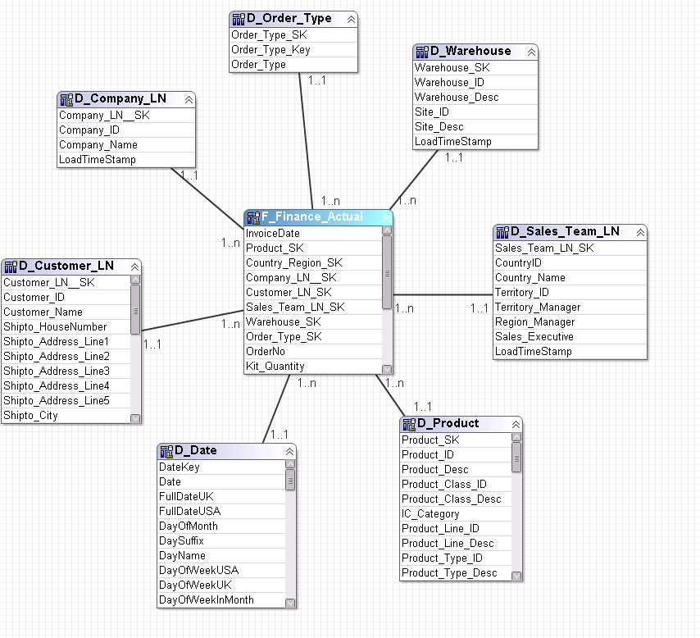

Fact: F_Finance_Adjustments

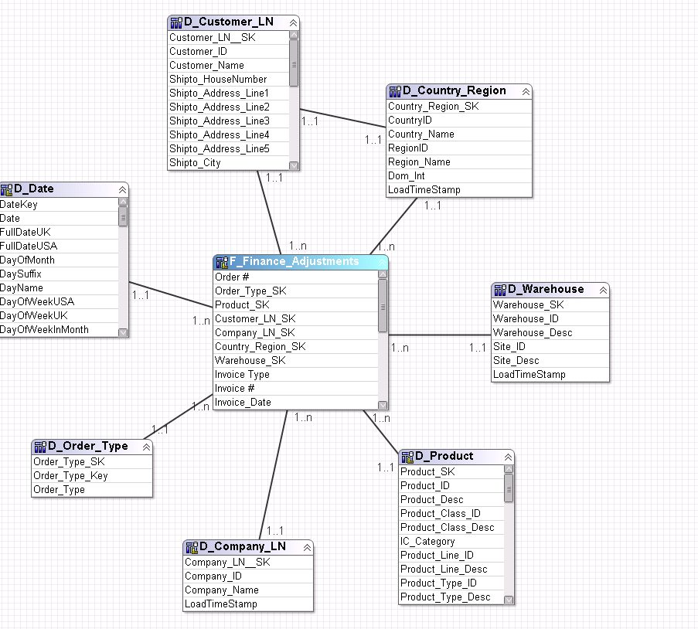

Fact: F_Finance_AOP

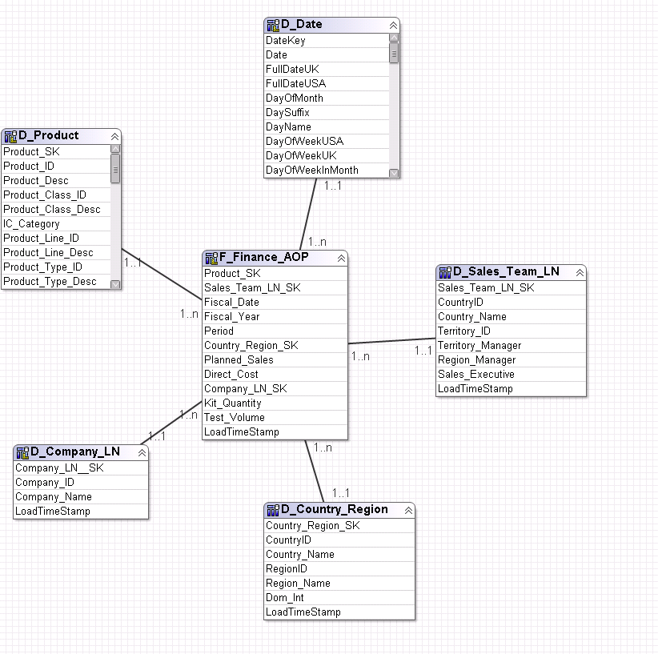

Fact:F_Finance_AOT

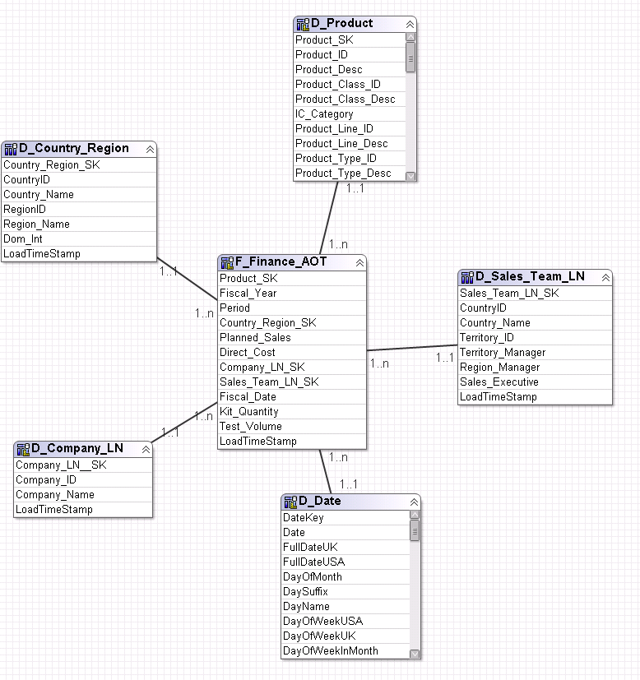

Fact: F_Finance_LBE

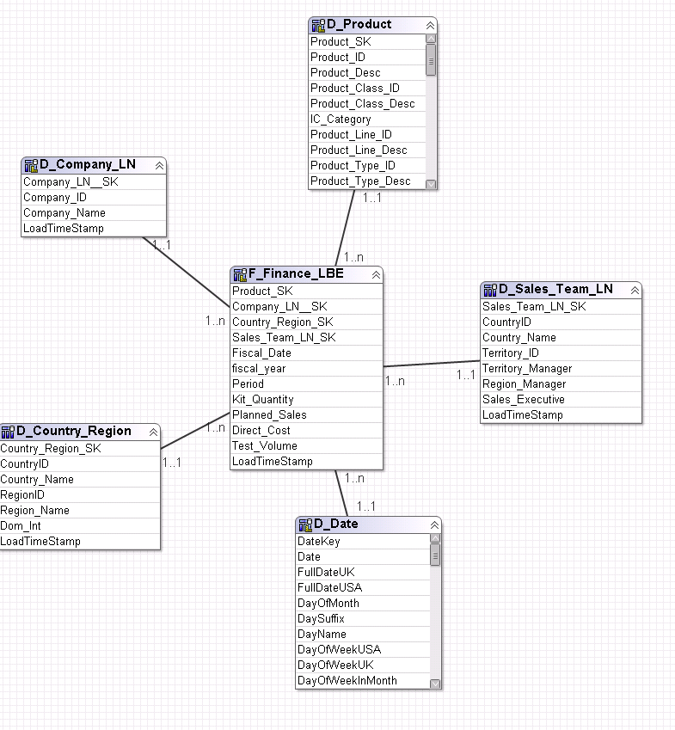

Fact:F_Finance_LBE_CY

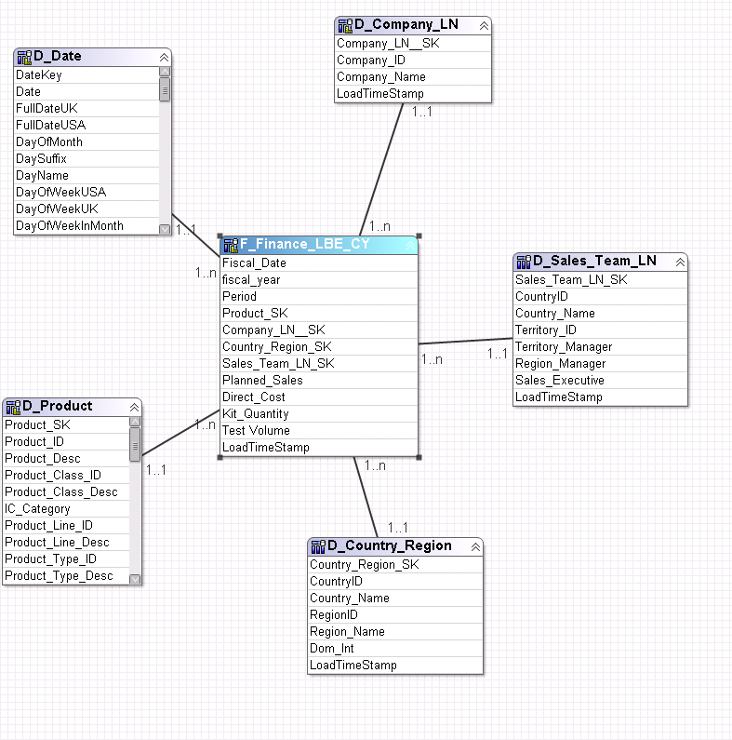

Fact:F_Shipments_Daily

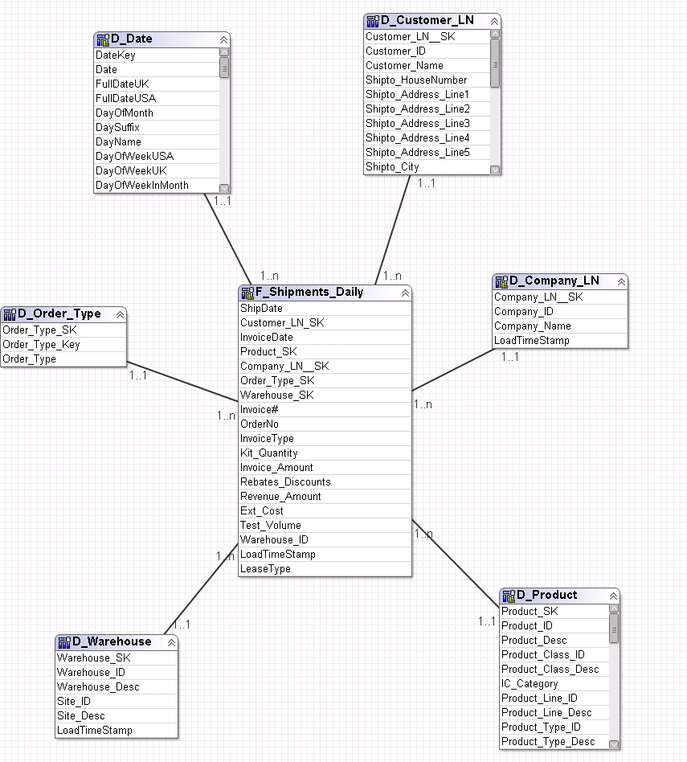

Fact:F_Shipments_Daily_Unbundled

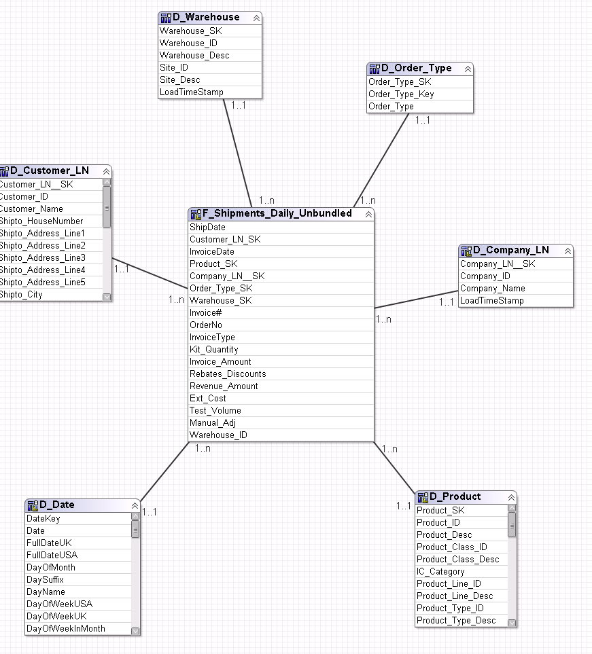

Fact:F_Shipments_History

